Navigation
Activity: Handrail Maps

Learning Objective: Learn how to use handrails

Orienteering is a sport that requires some problem-solving skills. These skills are needed to be able to effectively navigate between the controls that make up the course. One of these skills that we will be working on today is using handrails.
- Handrail: A prominent linear feature that the orienteer can follow on their route towards the next control. e.g.road, path, stream, vegetation boundary, fence...

Instructions:
- Print off the maps down below
- Draw your own orienteering course on each map thinking about how you would get between controls and how you would use handrails.
  - Remember that the start symbol is a triangle and the finish symbol is a smaller circle inside a larger circle.
  - Make sure to think about how you will be crossing fences (look for openings) and how you will be crossing rivers (a bridge may be necessary).
  - This colour means this area is out of bounds (usually reserved for residential areas or flower beds). Do not put a control in an area that is this colour and avoid creating a route where people would be tempted to cross it.
  - Easy: Riley Park
  - Medium: Prince’s Island Park
  - Hard: Fish Creek Park Glennfield
- Feel free to post photos of your maps on the SOGO Adventure Running facebook page!

Equipment:
- Printer
- Pens and pencils
- Activity map

Example Map, Canmore Park:

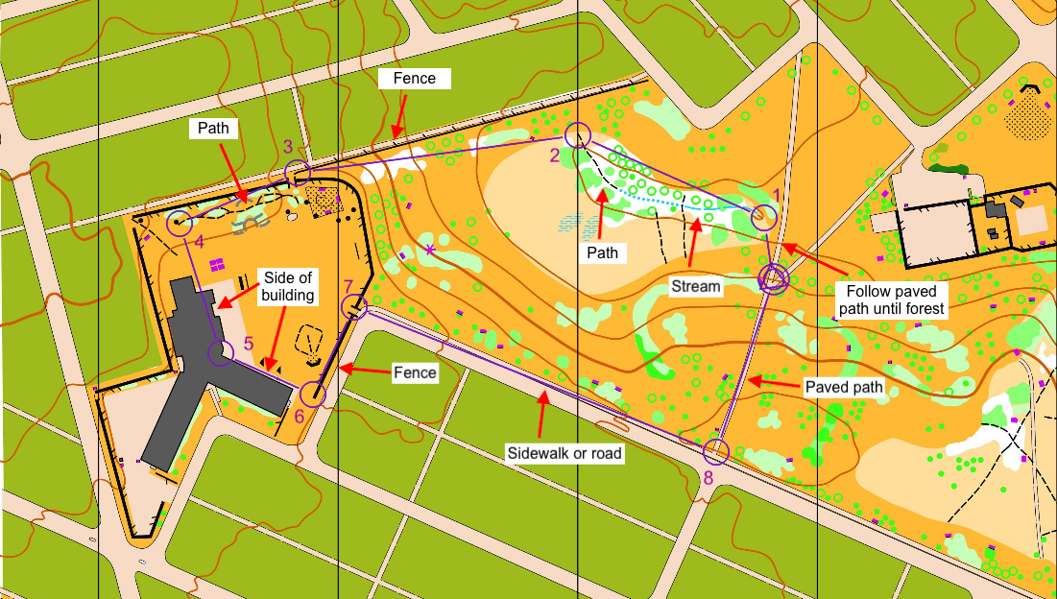

Easy - Riley Park
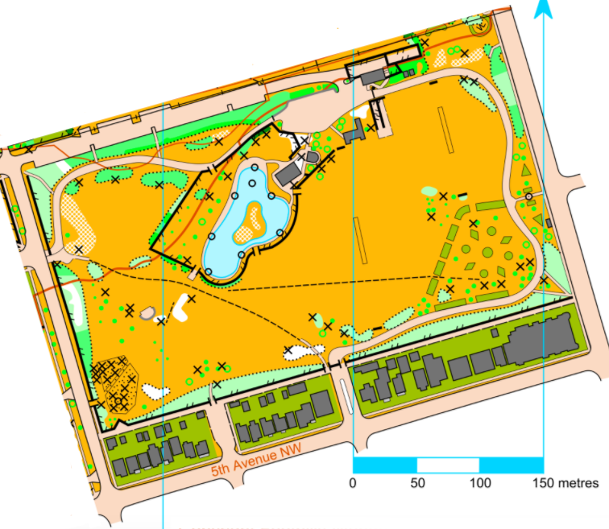

Medium - Prince’s Island Park
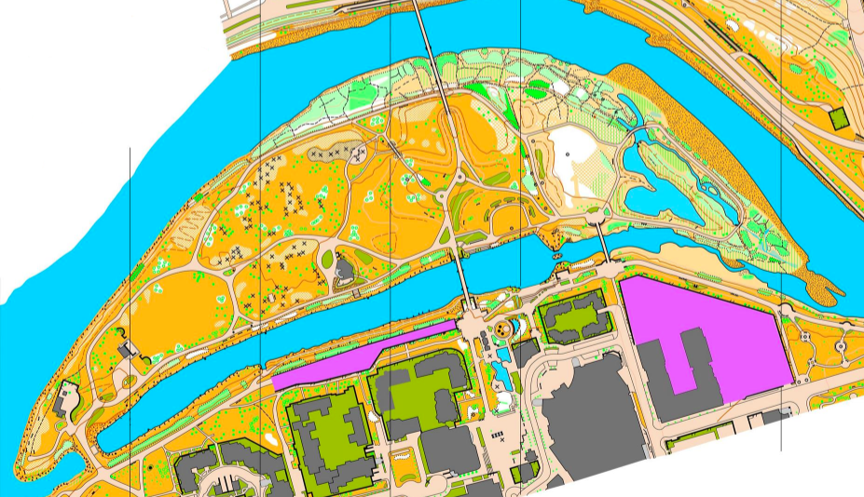

Hard - Fish Creek Park Glennfield
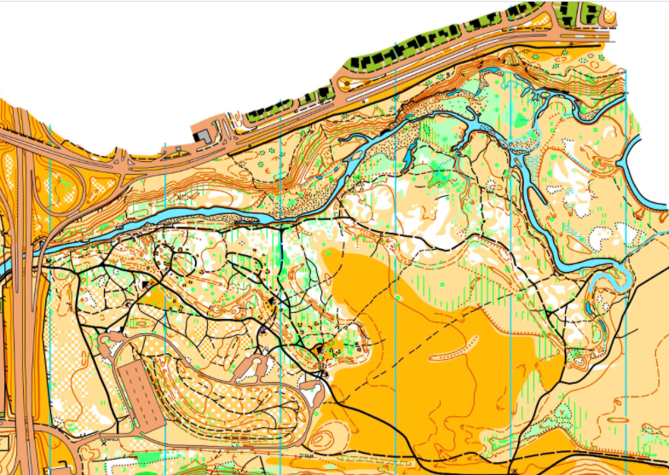

Endurance
Activity: Hanging Flags

Learning Objective: get kids running , memorizing your surroundings

Instructions:
- Print and cut out the flags (down below)
- Hang up 10 flags randomly around an area in your house or community.
- Time yourself getting to each flag in any order.
- Time every lap after that and write the time on their arm.
- The goal is to run your loop as fast as possible

Equipment:
- Flags (down below)
- Tape/sticky tack (or any other way to hang up flags)
- Timer
- Marker

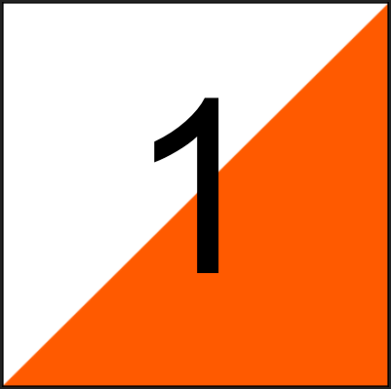 | 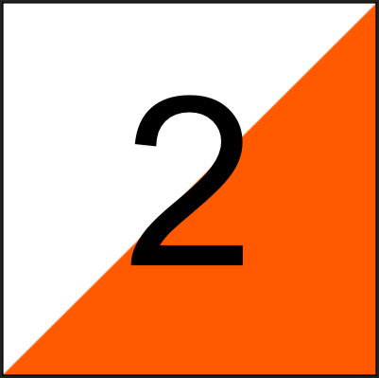
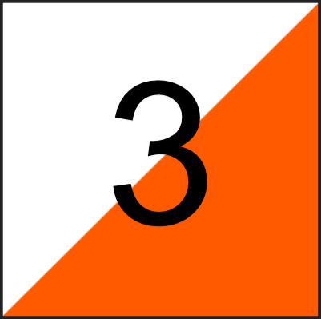 | 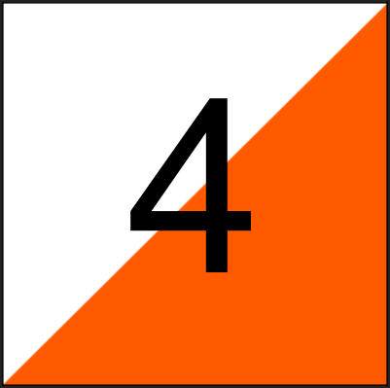

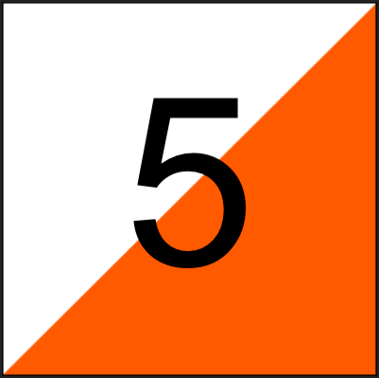 | 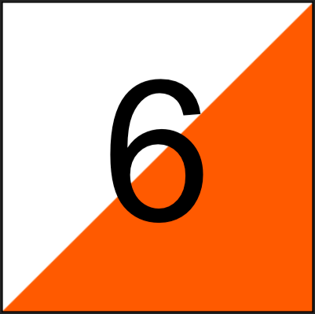
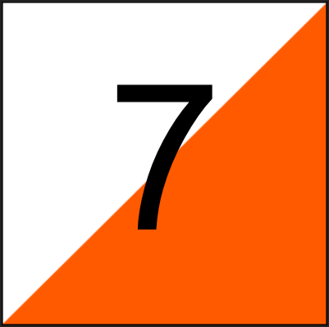 | 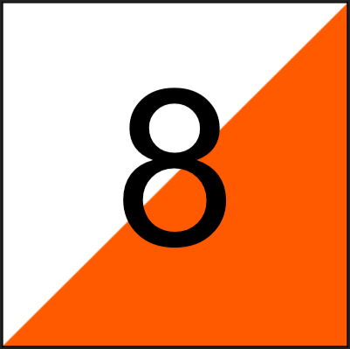

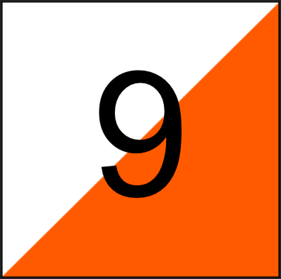 | 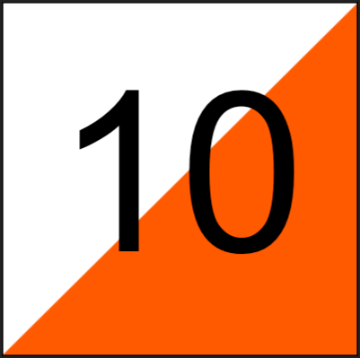

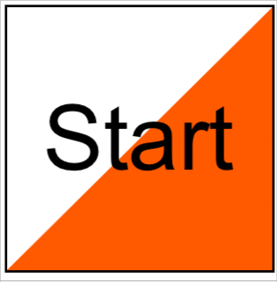 | 